CSA1708-ARTIFICIAL INTELLIGENCE
LAB EXPERIMENTS
Program 7 : Python Program to Implement BFS
Aim
To implement Breadth-First Search (BFS) and traverse a graph level by level from a starting node.
Algorithm
1. Create a graph and select the starting node.
2. Add the starting node to a queue and mark it visited.
3. Remove the first node from the queue and add it to the traversal order.
4. Add each unvisited neighbor to the queue and mark it visited.
5. Repeat until the queue is empty, then display the traversal order.
Program
from collections import deque

graph = {
"A": ["B", "C"],
"B": ["D", "E"],
"C": ["F"],
"D": [],
"E": [],
"F": []
}

start = "A"
queue = deque([start])
visited = {start}
order = []

while queue:
node = queue.popleft()
order.append(node)

for neighbor in graph[node]:
if neighbor not in visited:
visited.add(neighbor)
queue.append(neighbor)

print("BFS Traversal:", " ".join(order))
Sample Input
Starting node: A. The graph is defined in the program.
Program Execution
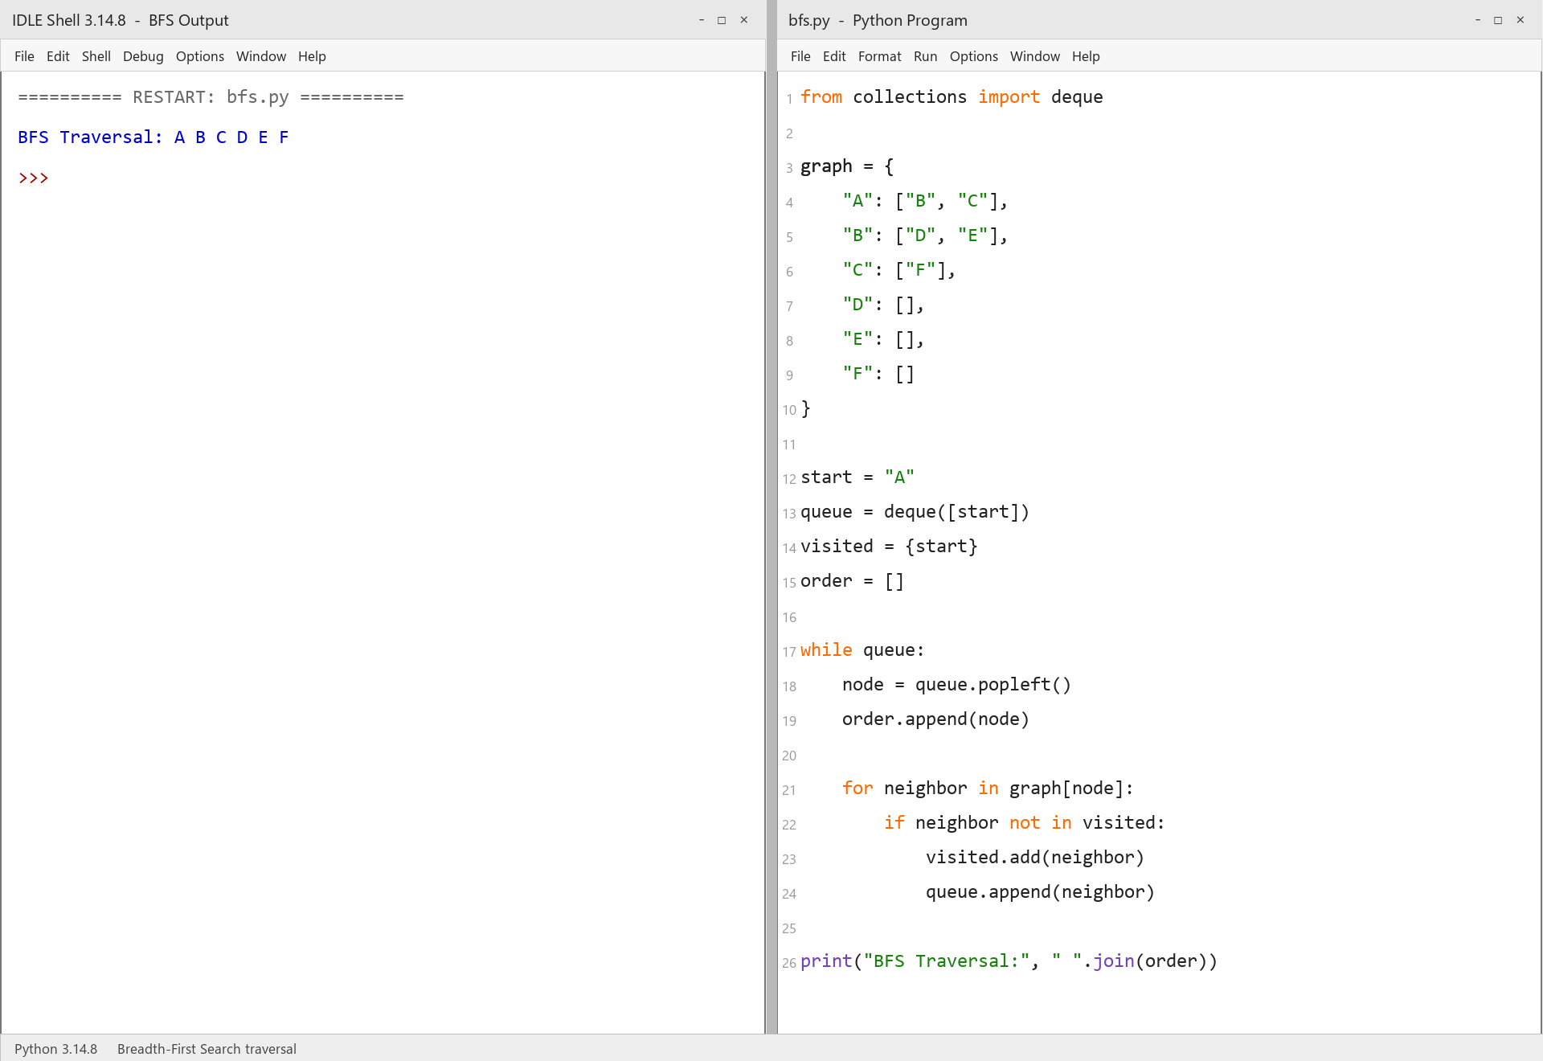
RESULT
Thus, graph traversal using BFS was implemented successfully using Python.

